**Attribute Creation Instruction**

**Instruction:**

* Data file must in same format as provided with the script
* Data file format must be ‘.xlsx’
* Dynamic Url Data type attribute will not work with this script.
* Before entering values into data file all the column format should be set as ‘Text’.
  + Note: If all columns are converted into text after entering the value, It will create problem with the numeric values.

**Configuration file:**

**Common Variable:** All the common variable must be set in configuration file.(For more details please refer common Help document)

**Attribute creation related information:**

* **Entity:** This variable is used to specify entity under which we want to create attributes.

For example: If we want to create attributes under **Test** entity then will mention Entity value as below:

**Entity=Test**

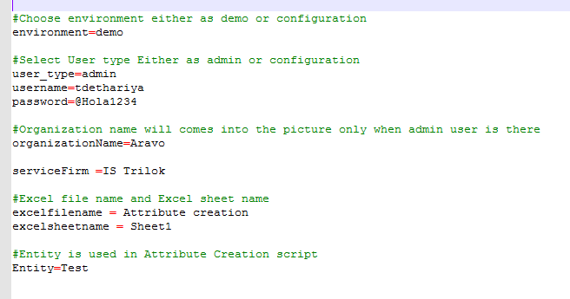

**Data File:**

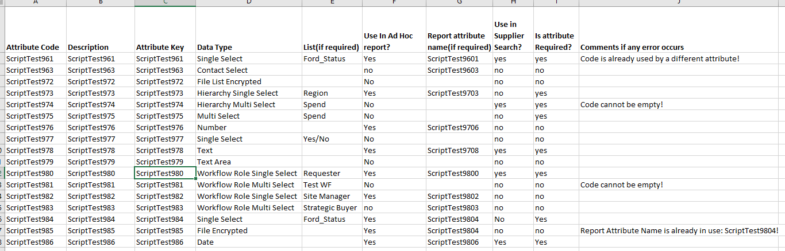

* **Attribute Code:** code of the attribute which you want to create
* **Description:** Description of the attribute
* **Attribute Key:** Attribute Key of the attribute
* **Data Type:** Type of the attribute
* **List(if Required):**  List is required when data type =’Single select’ or ‘Multi Select’ or ‘Hierarchy single select’ or ‘Hierarchy Multi Select’ or ‘Workflow Role Single select’ or ‘Workflow Role Multi Select’.
  + List name must be same as application’s List name
  + If list is not provided than it will give an error
* **Use in Ad Hoc Report?:** Select ‘Yes’ if attribute needs to be reportable, else select ‘no’
* **Report attribute name(if required):** If ‘Use in ad hoc report?’ = ‘Yes’, Need to specify the name of the Report attribute or else it is not required.
  + If ‘Use in ad hoc report?’ =’Yes’ and Not provide Report attribute name than it will give an error.
* **Use in Supplier search:**  Select ‘Yes’ if attribute is required in supplier search
  + ‘Use in supplier search’ is working only when ‘Use in ad hoc report?’ = ‘Yes’
  + For exp.: if ‘Use in ad hoc report?’ = ‘No’ and ‘Use in Supplier Search’ = ‘Yes’ then it will create attribute without selecting any options for ad hoc report or supplier search.
* **Is attribute Required?:** This column is used when any attribute needs to be created with required validation. Select ‘Yes’ if attribute is required or else select ‘no’.
* **Comments if any error occurs:** This field should be used in script and give the output after execution of the script. No input should be there before execution.
  + After execution if this field is blank that means Attribute created successfully.
  + If any error occurs during the script it will give the comments based in the error type.
    - For example: ‘Code cannot be empty!’, ‘Code is already used by different attribute’ etc.

**Steps:**

1. Prepared Configuration file as per requirement
2. Prepared Data files as per requirement
3. Run the file